Harsha

Raveendra Rao K, Manipal Institute of Management, India
Pallavi Upadhyaya, Manipal Institute of Management, India

Abstract: Retail sector is one of the biggest employers in India after agriculture. Traditionally, this sector was unorganized and very few players in the organized retail. There are several new Indian players such as Reliance entering in the organized retail segment. On the other hand, with several foreign retail giants such as Wal-Mart, Carrefour, Tesco and Casino actively seeking local partners, competition will be fierce. However the biggest challenge for them in India is diversity in culture, language and living styles.
This case is about one of the fastest growing retail chain in coastal Karnataka, ‘Harsha’ which has grown from a small town consumer electronics store to a retail chain operating 8 retail outlets in several places in costal Karnataka selling more than 8000 different items in more than 70 categories. The case examines the various aspects of retailing - products mixes, advertising and promotions, inventory management, after sales services, information management and human resource management at Harsha. The case provides the complete picture of a retail chain and makes it easier to analyze the various retail strategies adopted by Harsha to be the market leader. The case analyses the challenges that might be faced by the company with the ongoing retail competition.

Keywords: Retail Management, Consumer durables, organized Retail
Introduction
Mr. Suryaprakash, Managing Director is happy about the growth of Harsha but concerned about increasing competition in the organized retailing sector and wants a concrete strategy for Harsha to increase the volume and profits. He agrees with Mr.Ashok, Director (Operations) and plans for rapid expansion of the number of retail outlets. They agree that entering metro cities like Bangalore, Chennai and Hyderabad is not a feasible alternative for Harsha even though volumes might increase to a large extent, stiff competition in these markets might keep their net profits very low. Rising real estate rates and high employee turnover will bring profit margins down to a large extent.
After hours of discussion with Mr. Harish, Director (Marketing), Suresh, Director (Sales) and Rajesh, Director (Merchandising), the board decides the following two phase strategy for Harsha. In the first phase, they plan to increase the Harsha outlets to 40 numbers in tier II cities of Karnataka, followed by integration of all Harsha outlets using ERP software for better control and visibility. To provide a unique shopping experience to consumers, they plan to have all forthcoming outlets as 25,000 sq.ft. air-conditioned showrooms with multiple brands in every category. The Phase two plans includes making the presence of Harsha in 5 states by 2011, associating with leading retailers of south for pooled purchasing and importing. They also plan to make Harsha as a complete durable shop by including all durable products (Door mat to bathroom accessories to consumer electronics).

Retail Sector in India
Retail sector is one of the biggest employers in India after agriculture, employing about 6-7 per cent of the total work force ( The Economic Times, 2007). India's retail sector, which accounts for about 9-10% of the country's GDP, remains one of the least developed sectors in India. Traditionally, this sector was unorganized dominated by local kirana stores and very few players in the organized retail. According to AT Kearney, India is considered as the top retail destinations world over. The country’s underserved US$330 billion retail market has grown by 10 percent on average per year over the past five years. This market is among the most fragmented in the world; the combined market share of the top five retailers totals less than 2 percent. [AT Kearney, 2007] .With several new players from India such as Reliance, Bharti entering in the organized retail segment and many foreign retail giants such as Wal-Mart, Carrefour, Tesco and Casino actively seeking local partners, competition will be fierce. These foreign players have advantages of economies of scale and good technology. However the biggest challenge for them in India is diversity in culture, language and living styles. India is estimated to have around 15 million retail outlets, making it the country with the highest retail outlet density in the world. (See Figure 1)

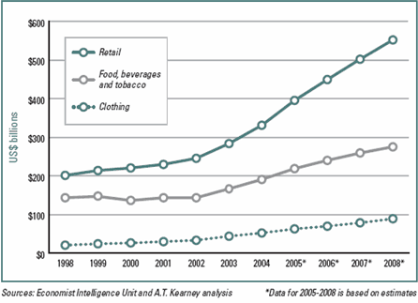
Figure 1 : Retail sales in India
Retail boom in India has just started and there are several formats and retailers are in the experimentation stage. The retail formats differ in considerably in metros , tier II cities and in rural places. The products, pricing are also varied. Some of the retail formats in modern India are Shopping malls, speciality stores, discount stores, department stores, convenience stores, MultiBrand Outlets(MBOs), and Hypermarkets/Supermarkets. Shopping malls are one of the largest forms of organized retailing today mainly seen in metro cities with an amalgamation of product, service and entertainment. Hypermarkets/Supermarkets cater to wide variety of consumer needs with self-service and contribute to 30% of all food and grocery retail sales. Specialty Stores such as the Bangalore based Kids Kemp, the Mumbai books retailer Crossword, RPG's Music World and the Times Group's music chain Planet M focus on specific market segments and have established themselves strongly in their sectors creating a brand of their own. Discount Stores or factory outlets offer discounts on the MRP through selling in bulk reaching economies of scale or excess stock left over at the season. The product category can range from a variety of perishable/ non-perishable goods. Discount stores such as Subhiksha, Janatha Bazaar etc have been in the scene since long time. Department Stores are large stores catering to a variety of consumer needs and have localized departments such as clothing, toys, home, groceries, etc. Among these, the biggest success is K Raheja's Shoppers Stop, which started in Mumbai and now has more than seven large stores (over 30,000 sq. ft) across India. Convenience Stores are smaller stores located near residential areas and stock a limited range of high-turnover convenience products and are usually open for extended periods during the day, seven days a week. Prices are slightly higher due to the convenience premium. Multi Brand outlets offer several brands across a single product category. These usually do well in busy market places and Metros.
According to AT Kearney report, given rapid commoditization and cut throat competition, consumer electronics retail lags other sectors in international retail expansion. Most consumer electronics retail companies are national or regional and have not focused on global expansion. Also, internet retailers such as Amazon, Dell and eBay already have a significant presence in a number of key foreign markets. But the pressure on margins and heightened local competition means consumer electronics retailers need to gain scale through international expansion and consolidation. (AT Kearney, 2007) In southern India, few players such as Vivek’s, Girias etc have been able to establish their niche in the consumer electronics market.
Harsha Retail
Harsha is an entrepreneurial venture of five brothers of the coastal town of Udupi.(See Exhibit 1). Started in 1987, with a floor area of 3000 square feet in small town of 60000 population, Harsha was one of the biggest retail showrooms in coastal Karnataka during that time. Harsha is now leading retailer competing with many well known retail chains of Karnataka, dealing with almost all major brands in all product categories.
Harsha is owned by Prakash Electric Co. Pvt. Ltd.(PEC) which has a history of more than 30 years. The company was an entrepreneurial venture of Mr.Surya Prakash, eldest of five brothers. In 1975, after passing out from PUC and with a seed money of Rs. 3000 and 4 employees, he started a small manufacturing unit which produced wooden switchboards. The idea was to use the wooden pieces from the father’s wood business which would simplify their raw material procurement. The company at that time had the problem of production as it could not fulfill the orders in time. In 1979, the company bought a saw mill which was a major milestone for the company. In 1980, along with younger brother, Ashok ,they implemented line production system and the result was improved output. In this system, the process such as cutting, marking, polishing, assembling of wood etc was split and assigned to one or two person. Each person contributed to a part of the production process and then passed on to the next level. This not only simplified the process and reduced errors but also enhanced the skill level of workmen. This however created a new challenge for marketing these switchboards. Even though the product quality and pricing was considered good at that time, the company could not get volume sales as the brand was new and there were already renowned brands in the market. The increasing cost of sales and piling inventory of switchboards was a growing concern. To address this, company added more products to the line of offerings such as electrical accessories such as plugs, cables , electrical appliances and irrigation pump sets. The Prakash Engineering Company was thus born. It was initially started as an distribution business of three brands Khaitan fans, Best pumps and Indocorp switch gears. The company later expanded slowly distribution of Mixers, Stabilizers, Pressure cookers, Grinders, Water purifiers, Cables, CFL Lamps, Iron box and Refrigerators. In 1985, there was new problem of excess stock and average stock turnover was around three months. With a passion for growth and to enable easy rotation of stock, the company thought of establishing its own retail outlet in 1987. During that period, there was huge demand for television sets in Udupi which made the company to add television and electronic durables to its retail. On March 9, 1987 Prakash Electric Co. Pvt. Ltd established Harsha (Stands for Joy) appliances retail outlet with a vision to provide all the items and products required for a family under one roof. Mr. Ashok, Director (Operations) proudly says “We are in the business of creating happy families”. With a punch line “Grahiniyara Kanasina Malige”(Housewives Dream shop), Harsha has been able to establish itself as an perfect consumer durable shop. With more than 20 categories and 800 SKUs, Harsha was launched in Udupi with more than 3000 sqft floor area for merchandising, which was something new to consumers of Udupi. With the launch, Harsha announced Rs. 500 discount on television sets which was a shock at that time for a small town like Udupi. They made sales worth 1.2 crore in the first year. Since then the company has never looked back. In a short span, it has expanded from a simple electronic store to 8 retail outlets in several places in costal Karnataka (See exhibit 2) selling more than 70 different categories and 8000 SKUs such as kitchen accessories, electronics, electrical items and the like. The company’s sales turnover is 72 crore today and company plans to reach the target of 100 crore by 2008. (See Figure 2)
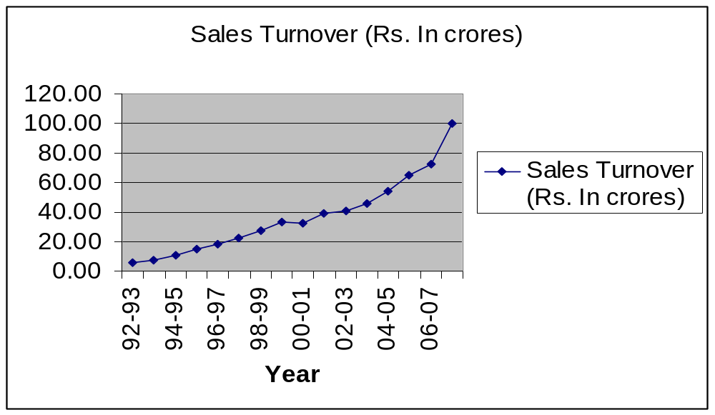 *Projected sales figure for 2007-08
100 crores*
Figure 2: Sales turnover of PEC
Merchandising, Sales and Service at Harsha
Starting with select consumer electronics and electrical items, Harsha now sells more than 70 categories of products and 8000 SKU(Stock Keeping Units) such as Refrigerator, Washing Machine, Television, Audio Speaker, DVD Players, digital cameras, mobile phones, personal computers, Home Theater systems and several kitchen accessories such as Microwave Oven, Mixer, Toaster, Non Stick Cookware, OTG (Oven Toaster Griller), Gas stoves, Food Processor, Coffee Maker, Hand Mixer, Kettle, Stick Blender, Bottle Opener, Juicer and also various home items such as wall clocks, Air Conditioner, Fans, Iron Box, lights, watches etc. The decision to add a new item is done based on the product quality, company brand image and customer feedback which Harsha collects annually since inception.
Prices for different items are decided according to different market conditions after careful study of competitors pricing. Harsha offers discounts on MRP on most of the items sold and the amount of discount on items depends on the markets they are operating.
Exhibit 3 shows the floor plan and counter arrangement for different products at Harsha, Udupi. Counter 2 on the left displays various electrical items such as lights, iron box, table fan, and gas stove etc. Counter 2 on the right displays watches, wall clock, water heaters, air coolers etc. Counter 1 on the left displays crockery, knifes and other kitchen accessories. On the right Counter 1 is the display of pressure cookers, mixers, grinders, coffee makers etc. Counter 3 is open counters with the display of television, audio and video system and a small sub counter with a display of items such as mobile handsets, digital camera etc. Counter 4 is also an open counter with the display of bigger items such as refrigerator, washing machine, microwave oven, air conditioner etc.
Every counter in the retail outlet has a supervisor and 3-4 sales persons. All the sales persons undergo an induction program, training on personality development, selling skills and product training from the company. Harsha has a very transparent working environment and the sales people frequently interact with the directors. The company provides after sales service to all its major electronic durables. “We take customer’s complaints seriously as they are our brand ambassadors” says Mr. Suresh, Director(Sales and Service). Initially the company had its own in house service personnel to provide after sales service. Even though now the service is provided by the service personnel of the manufacturer deployed in the city, Harsha ensures that every customer complaint is given due attention. In order to do this effectively, the customer first places the complaint with Harsha, the Harsha then routes it to the respective service personnel who attends the complaint and reports back to Harsha.
PEC has also continued with the distribution business and their warehouses supply products to other sub-dealers and retailers in all the cities they are operating.

Sales Promotions
The company organizes several special events such as Harshotsava, Monsoon Magic, Diwali Bazaar, Happy times, Exchange Mela, loan fest etc to promote its products and boost sales. Harshotsava is the anniversary function of Harsha and is a 6 days event successfully conducted since first year. Harsha has special offers for customers (Special discounts on all items, lucky draw on purchases with attractive prizes, games for customers inside the outlet with attractive prizes for winners) and a festive environment is created. The outlets are decorated with fresh flowers daily and welcome drink (from reputed caterer of the place) is offered to all visitors to the outlet. During rainy season, Harsha organizes Monsoon magic to create a buying environment and it offers special discounts on washing machines and TVs, exchange offers, free gifts, etc. To keep up the festive environment during the grand festival, Diwali, Harsha organizes Diwali Bazaar. During Christmas and new year, Harsha organizes a 15 days long sales festival called Happy times and there are attractive schemes like gifts, discounts, installment schemes, specials offers etc. During April and May, it organizes Exchange Mela in which the customers bring their old products and take back a new product for some additional price. Harsha often provides financial assistance to its customers in the form of loan fest. In this event, various financial institutions like Bajaj Auto Finance, Citi Financial Retail Services India Ltd., Country Wide Consumer Finance Company Pvt. Ltd. and ICICI Bank Ltd. provide financial assistance to customers who purchase from Harsha.
Table 1 shows sales during promotional events. During the promotional events daily targets are set for each branch and at the end of day; the branch manager discusses that day’s sales and target achievements and plans for next day in consultation with Director (Operations). Prakash Electric Co.(PEC) is known for its excellent advertising. PEC has made use of advertising very effectively to promote the various schemes and build their brand image through its memorable advertising strategy. Apart from print media Harsha also uses large number of hoardings in the cities which they operate. During events, local cable television advertising is also done to promote the events. Every year Prakash Electric Co. spends about Rs. 2 Crores towards advertising. Exhibit 4 and 5 shows the sample advertisements of Harsha.

Table 1: Sales during promotional events at PEC (Rs. In crores)

Year | Total | Harshotsava | Mansoon Magic | Diwali Bazaar | Happy Times
01-02 | 39.21 | 3.65 | 3.67 | 5.3 | 1.98
02-03 | 40.77 | 4.74 | 3.85 | 4.94 | 2.06
03-04 | 45.63 | 5.47 | 3.62 | 6.12 | 2.49
04-05 | 54.05 | 6.07 | 6.23 | 8.12 | 2.97
05-06 | 64.97 | 7.94 | 6.48 | 9.46 | 3.72
06-07 | 72.88 | 9.11 | 7.82 | 9.71 | 4.42

Stock Handling at PEC
Prakash Electric Company has categorized products into two varieties for stock keeping purpose. Small sized items like mixers, iron boxes, flasks, mixer grinders etc are stocked in the central warehouse located at Udupi and supplied to various branches as per requirements. Larger items like TVs, refrigerators, washing machines etc are stocked in the warehouse located at the Harsha outlets of respective towns. Harsha has fixed minimum level of stock for all the items to be stocked in the warehouse of outlets based on a computer assisted inventory program. The minimum stock level is calculated every month considering the sale of items and market conditions. The various manufacturers on a regular basis supply the stock of smaller items to the main warehouse at Udupi. In cases of stock out situations, items are adjusted from nearby outlets after informing the head office. The manager at the retail outlets report regularly about sales and requirements to the Director (Operations). All these operations are done with the help of email and through telephone when the requirement of the product is urgent.
As soon the products are received at warehouses of branches or central warehouse, all items are checked for defects, if any and immediately informed to the concerned supply for replacement or repairs. PEC owns a fleet of delivery vehicles which distributes to various outlets from the central warehouse.

Information Systems at PEC
Currently Harsha is using a decentralized point of sale application at all its branches named Inform Accura developed by Keystrokes, which is customized application developed 18 years back in FoxPro. The maintenance is done currently by the company itself. It cost them approximately Rs. 30,000 to develop and install the software. The software has been updated several times and today it would cost about Rs.2 lakh, according to Mr. Ashok.
All the transactional data at the retail outlets and at the distribution center are captured through the Inform Accura applications. All the day to day transactions such as entries of invoices during sales, maintaining product price list, payments to suppliers, delivery , branch stock-in and stock-out details, stock returns to supplier, stock status in warehouse and in branches are captured through the application. At the retail outlet, the materials manager uses the application to forecast the demand based on the last weeks sales data and send the purchase requisition to the head office. Since the application is decentralized, backup of every day transactional data from all the branches is sent by courier to the head office at Udupi. The company does not bear extra costs on this as the backup is always sent with other communication between branches. At the head office, the Inform Accura is used extensively to analyze the sales data. The sales personnel performance, counter wise and category wise sales performance analysis are some the regular analysis done. The purchase requisitions from various outlets are compiled and the purchase order to the respective supplier is sent centrally. For specific and ad-hoc reports, FoxPro data is imported to excel and reports are generated. The company uses Lotus Notes for easier and secure communication between the head office and various Harsha outlets. Tally application is used for accounting and some transactional data are redundantly maintained in Tally and Inform Accura.
The Prakash group also operates its own software company Prakash Business Solutions which was started in 2001 in collaboration with ‘Unison’ a leading software development firm of Coimbatore. They developed retail ERP software and have sold more than 50 licenses to various retailers. All the retail outlets of Harsha have CCTV cameras and can be monitored at head office through broadband connection.
The company plans to implement SAP Retail solution to support interconnectivity between various branches. The company’s vision is to improve its visibility and control with minimal management interventions through the new application.

Human Resource Management
More than 300 employees work for Prakash Electric Company. “Staff turnover is very common in retail industry, but it is less in PEC”, says Mr. Amin. All staff are carefully selected by Director (Operations) and the human resource department. All the employees of Harsha are given free accommodation in the respective cities. Whenever a new outlet is opened, about 60% of staff is deputed from the Udupi outlet and the rest is locally hired. All Staff undergo an Induction and training program at head office immediately after appointment. The company bears most of the food expenses of the staff. All employees have incentive on sale in their city as percentage of their basic salary. Harsha believes in having transaparency between management and the employee.
PEC organizes an annual gettogether every year on August 15th, the Independence Day on August 15th since inception. All the staff from different cities assemble at head office for the celebration. “It’s a Harsha family event. Its paid holiday and this event makes all employees feel it is their organization and motivates them” says Mr. Nagappa Amin, Senior Manager (HR). Figure 3 shows the retail store reporting structure.

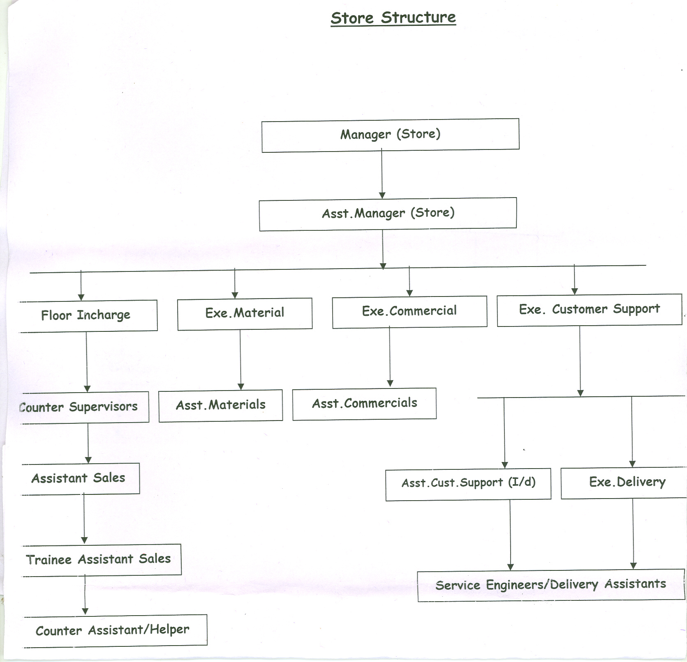

Figure 3 : Reporting Structure at Harsha Outlets

Competition and Future
Harsha has been the leader in the electronics retail in Udupi since its inception. Only one competitor Souza Electronics competed with them in the electronic space and format. But they lacked in terms of models available for display and aggressiveness in promoting their products. Recently with the entry of two more electronic showrooms in Udupi, Pai International(from Bangalore) and Sony exclusive showroom, the competition is taking off. With a new big player, Big Bazaar entering into the space with there would be lot of action in the retail market at Udupi. In India Reliance Digital, Big Bazaar big players have already entered electronics space and foreign players like Best Buy have plans. Harsha has successfully managed the competition in Mangalore from big players like Giriyas(from Bangalore), Pai Sales (from Bangalore), Big Bazaar, because of its better understanding of customers, professional management, better promotions and advertising and excellent after sales services.
From manufacturing to distribution to retail, the company has come a long way. The company is very clear about the retail format for Harsha. The company plans to keep only branded items only in all segments and provide more choice for customers in every segment.

Appendix

Exhibit 1: Board of Director’s Profile

SuryaPrakash K, Managing Director
Being eldest among the five brothers, SuryaPrakash has been the initiator and leader of the entrepreneurial venture of Prakash Electricals. He was instrumental for keeping the group intact and motivates people to look outwards for growth. With background in finance and Law, he looks after the finance aspects of the group.
Ashok Kumar K, Director (Operations)
A Mechanical engineer by qualification and with an experience in production, Mr. Ashok was first to define professional level and customer centricity in the company. He was the brain behind the group’s mega computerization project and was instrumental for getting Prakash Business Solutions India Private Limited to its current existence. He has gained respect as a perfect deal maker in the group. He also looks after the HR issues of the company.
Harish M, Director(Marketing)
With a MBA in Marketing from Bombay, Harish currently looks after Marketing of Harsha Brand. Apart from being a good listener and true professional, his skills of executing marketing strategies and presenting proposals are appreciated in the group
Suresh M, Director(Sales)
Also with an MBA in Marketing from Bombay, Suresh looks after the sales and under his supervision, sales have seen consistent growth. He was instrumental in restructuring of customer support and delivery wings. With an ever smiling face, he has been able to motivate his sales team to perform better.
Rajesh, Director(General)
Rajesh is the youngest director on the board and known as hardworking and soft-spoken. He currently looks after the general management of the group and also the retail outlet at Udupi

Exhibit 2 Harsha Retail Outlets

Name of the Retail Outlet | Place | Showroom Area | Year of Establishment
Harsha | Udupi* | 5000 sq ft | 1987
Harsha | Mangalore | 5000 sq ft | 1992
Harsha | Shimoga | 4979 sq ft | 1998
Super Shop | Mangalore | 1500 sq ft | 1999
Harsha | Hubli | 5425 sq ft | 2001
Harsha | Puttur | 5470 sq ft | 2003
Harsha | Kundapur | 4213 sq ft | 2004
Harsha | Belgaum | 25000 sq ft | 2007

*Harsha at Udupi started a exclusive furniture outlet branch at Udupi in the year 2000. The outlet houses all types of unbranded wooden furniture such as sofa, dining table etc and branded steel furniture in certain categories. Prakash electric Co. has a Distribution Center (7000 sq ft) at Udupi.

Exhibit 3: Harsha Udupi Showroom floor area*

Service Centre
Warehouse

Counter 3
Counter 4

Display Area
Display area
Display area
Billing area
Billing area
Counter 1
Counter 2
Counter 2
Counter 1
Entrance
Entrance

* Not to scale

